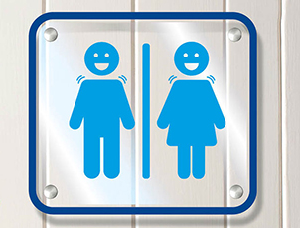
Flushed Away - It’s no joke!

A collection of pooptastic toilet jokes for
World Toilet Day 2015

What did one
toilet say to the other?
“You look flushed!”

What’s the difference between a lavatory brush and a chocolate biscuit?
- You can’t dip a lavatory brush in your tea!

“Knock Knock.”
“Who’s there?”
“I’ve done ap”
“I’ve done ap who?”

What’s an ig?
- An Eskimo’s house without a loo!

- “Knock, knock.”
“Who’s there?”
“Ahab.”
“Ahab who?”
“Ahab to go to the loo in a hurry!”

“Knock, knock.”
“Who’s there?”
“Butter.”
“Butter who?”
“ Butter be quick, I’m desperate for the loo!”

“Knock, knock.”
“Who’s there?”
“Stinkeep.”
“Stinkeep who?”

“Knock, knock.”
“ Who's there?”
“Smell mop.”
“ Smell mop who?”

What do you call a woman with two lavatories on her head?
- Lulu.

“Do you know anyone who’s been on the telly?”
“My little brother did once but he can use a potty now!”

What do you get if you cross a seagull with a parrot?
-A bird that poos on your head and then says ‘Sorry’.

Why did the baker have smelly hands?
Because he kneaded a poo!

“What are you going to do with that horse manure?”
“Put it on my strawberries.”
“Really? We put cream on ours!”

What do you call a small person who fills their nappy at a birthday celebration?
- A party pooper.

What did little William Shakespeare ponder when he was potty training?
"To pee or not to pee...that is the question."
Did you hear the joke about the toilet?
- Never mind it’s too dirty!
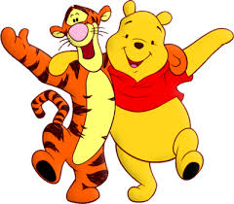
What do you get if you cross a bear with a toilet?
- Winnie the Pooh!

Why did Tigger stick his head down the toilet?
- He was looking for Pooh!

Where does Eeyore go to relieve himself?
- Pooh Corner!
What did Piglet flush down the toilet?
- Pooh!

Why is Tigger always dirty?
- Because he plays with Pooh.

What do you get if you cross Winnie the Pooh with a donkey?
- Diarr-Eeyore!

What did Mr Spock find in the toilet?
- The Captain’s log!

A man went to the doctor’s with a piece of lettuce sticking out of his bottom.
The Doctor said:”It’s just the tip of the iceberg.”

What is invisible and smells like carrots?
- A bunny fart.

Did you hear about the film Constipated?
It never came out.

Did you hear about the sequel, Diarrhoea?
It leaked so they had to release it early.

Toilet paper: what a rip off!

Did you hear about Robin Hood's toilet?
He had a "Little John"!

Some thieves broke into the local police station and stole all the toilets.
The police are investigating, but they have nothing to go on.

For Christmas last year I got given Sudoku toilet paper.
It’s useless. You can only fill it in with number ones and number twos.

Did you hear about the constipated accountant?
- He couldn’t budget!
Did you hear about the constipated mathematician?
- He worked it out with a pencil!

Did you hear about the constipated composer?
- He had difficulty with his last movement.
“There are two reasons never to drink toilet water….Number one and number two!”

Why did the toilet paper roll down the hill?
To get to the bottom!

Why couldn't the toilet paper cross the road? Because it got stuck in a crack.
We have a genetic predisposition for diarrhoea.
– It runs in our jeans.
Why did Dracula wet his pants?
He couldn’t make it to the bat room on time.

Why can’t you hear a Pterodactyl go to the toilet?
Because it has a silent P.

What did one fly say to the other fly?
“Is this stool taken?”

What's brown and sounds like a bell?
DunGgggg

What do you get when you poop in your overalls?
Dung-arees.

What poker hand did the poo win all his money with?
A royal flush

Which French town has two toilets?
- Toulouse!

What is brown and smelly and sits on a piano stool?
Beethoven’s last movement.

Happiness is like peeing in your pants.
Everyone can see it, but only you can feel it.

What is it called when the Queen farts?
A noble gas.

What's the difference between a museum and a Mr. Methane act?
One has artifacts; the other does farty acts!

Let us end with a lovely story!
For decades, two statues, one male and one female, faced each other in a park until one day, an angel came down from heaven.
"You've been such great statues," the angel said, "that I'm going to give you a special gift. I'm going to bring you both to life for thirty minutes, during which time you can do anything you want."
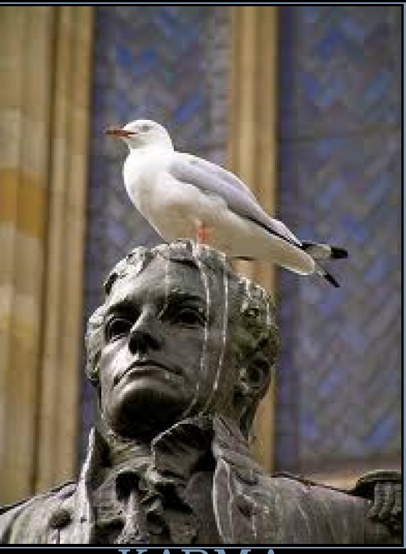
And with a clap of his hands, the angel brought the statues to life. The two dashed for the bushes, from whence there came a good deal of giggling, laughter, and shaking of branches. Fifteen minutes later, the two statues emerged from the bushes with wide grins on their faces. "You still have fifteen more minutes," said the angel, winking at them.
Grinning even more broadly, the female statue turned to the male statue and said, "Great! Only this time you hold the pigeon down and I'll poo on it's head!"

