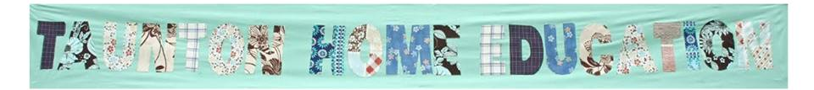
Membership Form
Name:
Child/Children:
Email:
Contact phone number:
************************************************************************
I allow/do not allow (please delete as appropriate) photos/videos to be taken of my child/ren and added to the website /facebook page

************************************************************************
Declaration:

I am resident in Somerset or one of the surrounding areas

I agree with the Aims of Taunton Home Education

I have read and agree to the T.H.E. rules

I have paid my membership fee of _____ via Cash/Cheque/ Bank transfer (please delete as appropriate). Note: fee for family membership for one year is £7.50 or £4.50 low income.
Signed:
Date:
NOTES:
- Bank details for payment of membership fee via bank transfer: Taunton Home Education. Taunton Home Education, The Co-operative bank, Sort Code 08-92-99. Account number: 65745119.
- Please read our Privacy Notice which sets out how we use and protect any personal information you give us.
- Once you have sent us your form and paid your fee you should receive a photo Membership Card and a Welcome Pack. If you do not receive these promptly please message Caroline 07473 119425.

