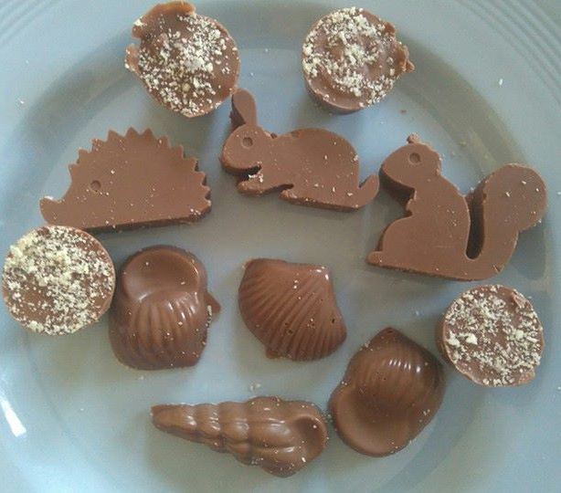
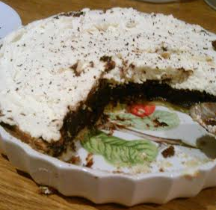
Cocoa Loco!
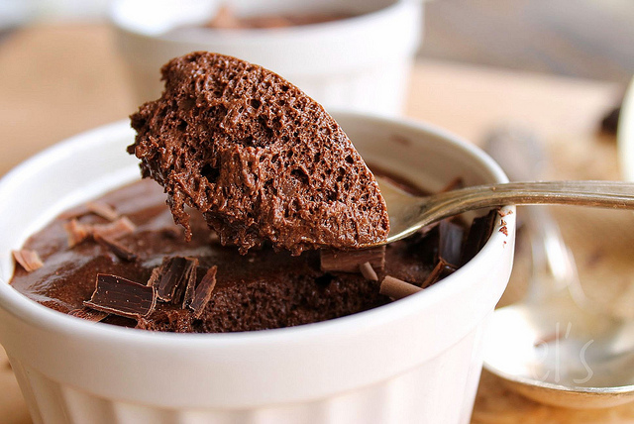
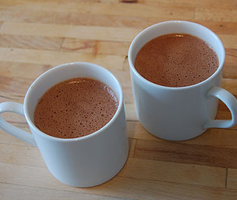
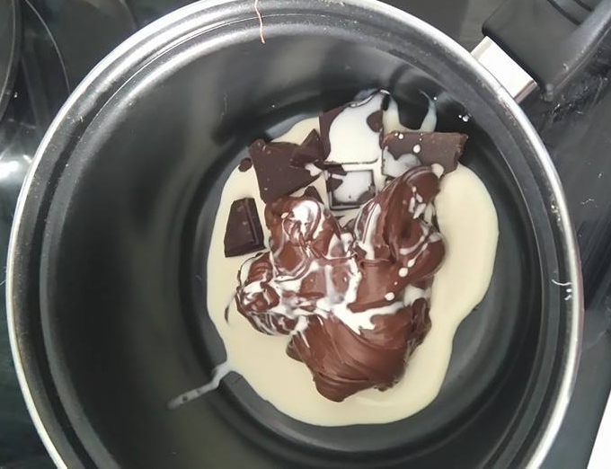
The Taunton Home Education Chocaholic Cookbook
Acknowledgments
Thank you to: Beth, Caroline and Felix, Pippa, Henry and Sam for sharing their recipes.
Contents
Aztec Hot Chocolate
Beauteous Brownies
Chocolate Coconut Fudge Brownies
Chocolate Celebration Cake
French Chocolate and Almond Cake
Chocolate Cupcakes
Mars Bar Cakes
Polish Cake
Chocolate Caramel Shortbread
Choc Chip Cookies
Mousse au Chocolat
Mars Bar Semifreddo
Mud Pie
Easy Chocolate Treats
Nutty Chocolate Truffles
Posh Chocolate Truffles
Raw Chocolates

Aztec hot chocolate

Ingredients:
- 150g dark chocolate, broken up
- 1 litre whole milk
- ½ - 1 tablespoon ground cinnamon
- 4-8 drops vanilla essence

How to make
- Heat the chocolate in a bowl over a saucepan with some hot water in it (or you can microwave it, but be careful not to burn it).
- At the same time, heat the milk gently in another saucepan, then add the vanilla and cinnamon.
- Add the melted chocolate to the milk, and bring to the boil.
- Simmer the mixture, whisking with a balloon whisk or hand beater for 2-3 minutes.
- Remove from the heat and keep whisking until you have a good layer of foam.
- Drink your chocolate hot or cold, but make sure each mug gets a generous layer of bubbles!

Beauteous Brownies
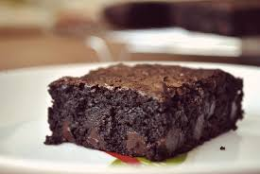
Ingredients:
- 3 eggs
- 200g caster sugar
- 100g butter
- 100g Dove’s Farm Gluten Free Self-raising flour
- 50 ml milk;
- 150g dark chocolate (broken up) plus about half as much again to add in in chunks.
How to make them:
- Warm your oven to 180 degrees.
- Grease and line your tin with greaseproof paper.
- Crack the eggs and whoosh them in a food processor until pale.
- Mix in the sugar, flour and milk.
- Melt the butter with the chocolate in the microwave and mix that in.
- Pour mix into the tin and add chunks of chocolate. Bake for 30 mins.
- Let it cool in the tin and then sprinkle icing sugar over if you like, chop up and scoff.

Chocolate Coconut Fudge Brownies
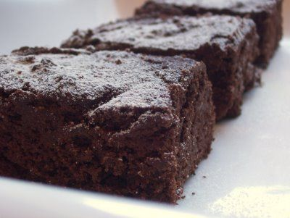
Ingredients
- 4oz Cocoa powder
- 9oz butter
- 6oz caster sugar
- 14oz malt extract
- 4 eggs
- 4 oz self-raising flour
- 4 oz dessicated coconut
How to make them:
- Grease and line a 9"square brownie dish.
- Set oven to 160'c
- Melt the cocoa powder, butter, caster sugar and malt extract over a low heat, stirring occasionally.
- Remove from heat as soon as butter is melted and combined.
- Add beaten eggs, stir briskly.
- Add the self raising flour and desiccated coconut. Stir to combine.
- Pour into dish, place in centre of oven for 30mins- check by lightly touching centre. Should be gently firm/bouncy. Leave for up to 45mins total max.
- Leave in dish to cool. Tip upside down to slice into 16 squares.

Chocolate Celebration Cake
Ingredients
- 200g butter
- 200g caster sugar
- 140g plain flour
- 2 Teaspoons baking powder
- 60g cocoa powder
- 4 eggs
- For the icing: 100g dark chocolate, 250g butter, 500g icing sugar
How to make it
- Preheat your oven to 180 degrees
- Cream the butter and sugar (whizz it up in food processor)
- Chuck in the eggs, flour, cocoa and baking powder and mix
- Grease and line 2 round cake tins – divide mixture between the two tins.
- Bake for 15 mins until cake tester comes out clean when you shove it in the middle
- Allow to cool and make the icing – gently melt the chocolate in bain marie or microwave then whizz in processor with the butter and icing sugar.
- When cakes are cool cover top of one with some of the icing, shove the other one on top and ice it, and smear icing all down the sides too. Then decorate and stick candles on.

French Chocolate and
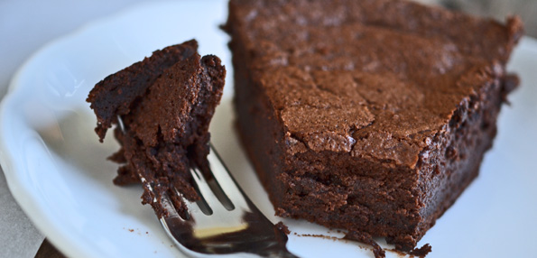
Almond Cake
Ingredients
- 150g dark chocolate
- 150 g sugar
- 150g butter
- 150 g ground almonds
- 4 eggs
How to Make
- Preheat oven to 160 degrees.
- Melt the chocolate in bain marie or microwave. Then add butter to it, mix in.
- Mix sugar and egg yolks together in a separate bowl – add the chocolate and butter mix to this and stir in the almonds.
- In another bowl or your food processor beat the egg whites till they are ‘en neige’/ form stiff peaks and fold them into the mixture.
- Bake for 45 minutes.

Chocolate Cupcakes
Ingredients
- 40g butter
- 140g caster sugar
- 100g plain flour
- 20g cocoa powder
- 1.5 teaspoons baking powder
- 120 ml full fat milk
- 1 egg
- Few drops vanilla essence
For the icing: 100g butter, 300g icing sugar, 40g cocoa powder, 40ml milk
How to make them
- Preheat the oven to 170 degrees.
- Bung all the cake ingredients bar the egg, milk and vanilla in a food processor and whizz it up until it looks like sand.
- Add the milk, beaten egg and vanilla and whizz again.
- Spoon into cupcake cases – about two thirds full and bake for 20-25 minutes (check them after 15). Note if your cases are verging on the muffin size you’ll get about 12 cakes out of this mix, if more standard little cupcake size up to 18.
- Leave to cool.
- Mix the icing ingredients up in your food processor and liberally smear on top of the cooled cakes (or pipe nicely in a nice swirl if you have the skill!) and decorate with cute things like hundreds and thousands or chocolate hearts.
Mars Bar Cakes
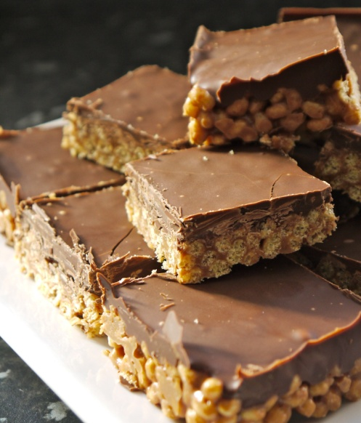
Ingredients
- 3 Mars Bars (the ones that weigh 51g each)
- 3 oz butter
- 3 teacups of Rice Krispies
- 200g Dairy Milk Chocolate
How to make it
- Chop up the Mars bars and put in a pyrex bowl with the butter.
- Sit the pyrex bowl over a pan of boiling water (make sure the bottom of the bowl isn’t touching the water) and let the mars bars and butter melt. (This is called a ‘bain marie’). Stir them together until they turn into a lovely caramel.
- Take the pyrex bowl off the pan and scoop the caramel into a mixing bowl. Then add the rice krispies and stir them into the caramel.
- Tip this mixture into a baking tray – spread it out so it’s nice and even and put in the fridge until it hardens. (check it every hour to see if it’s hardened).
- Melt 200g (at least!) of Dairy Milk Chocolate in a glass bowl in your microwave (or use a bain marie) and spread it over the krispie base.
- Pop it back into the fridge until the chocolate has set.
- This is the tricky bit! – Chop it into small squares. (Ask a grown up to do this)

Polish Cake
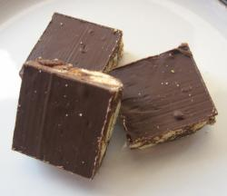
Ingredients
- 3 tablespoons golden syrup
- 4 oz margarine or butter
- 3 desertspoons cocoa powder
- Large packet of digestive biscuits
- Large bar of milk or dark chocolate
How to make it
- Melt in a saucepan 3 tbsp. golden syrup, 4oz marg or butter and 3 dsp cocoa powder and a generously large handful of sultanas
- Meanwhile crush 3/4 large packet of digestive biccies and then add these to the molten mixture
- Get a square 9" or 10" tin and press the mixture into it
- For the topping you will need to melt 1 large bar of either milk or plain chocolate (whichever you prefer) and then spread this over the top. To melt use a bain marie or the microwave.
- Fridge the cake for a couple of hours if you can wait that long and then cut into squares or slices of whatever size you need to cram into your waiting tribe of hungry chocomaniacs .....

Chocolate Caramel Shortbread
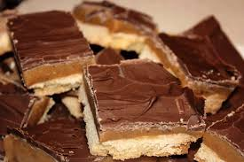
Ingredients
For the shortbread:
- 250g Plain Flour
- 75g caster sugar
- 175 g butter.
Plus: a tin of caramel and a 200g bar of Cadbury’s Dairy Milk Chocolate
How to make it
- Grease a baking tin (around 7 inches by 11 inches) and line with greaseproof paper, stick your oven on at 160 degrees. Get your ingredients weighed.
- Sieve flour into bowl, add sugar, mix. Then add your butter and rub it in till you have nice ball of dough.
- Roll your dough out (on a floured surface) to fit the tin and prick holes in it with a fork.
- Bake 25-30 mins at 160 degrees.
- Let the shortbread cool. Then spread caramel over the top evenly and chill.
- Once caramel set a bit melt your chocolate in a bowl in the microwave and spread that over. Chill again till chocolate set.
- Get it out, hack it up and enjoy!

Choc Chip Cookies
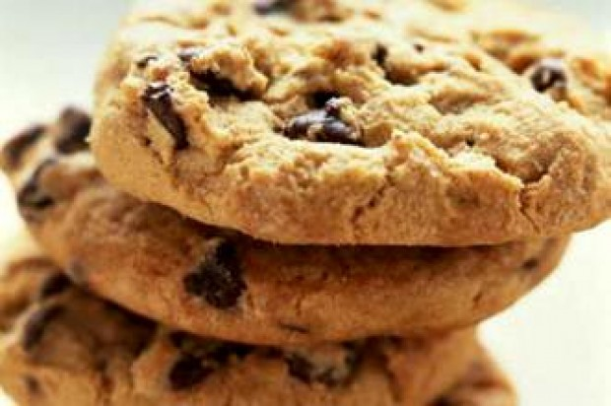
Ingredients
- 6oz plain flour
- 1tsp baking powder,
- 4.5oz marg,
- 3oz brown sugar
- 2oz caster sugar,
- half tsp vanilla flavouring,
- 1 egg,
- 4.5oz choc chips (or buttons, or crushed easter eggs!).
How to make it
- Chuck it all in a bowl, mix, spoon dollops of mixture onto baking trays spaced apart and hey presto!
- Bake at Gas mark 5 (190 degrees) for 10-12 minutes.

Mousse au chocolat
(serves 6 -8)
Ingredients:
- 6 eggs
- 200g dark chocolate (not fancy stuff – use one with low cocoa content. The chocolate needs to not be too bitter or it tastes foul)
How to make it:
- Separate the egg yolks from the whites.
- Put the whites into a food processor and mix until they go white and stiff (the test is if you scoop some up with a spoon and turn the spoon over the puffy white foam doesn’t fall off easily. You can use an electric whisk and a bowl if you don’t have a food processor).
- Meanwhile melt the chocolate in a bain marie or in your microwave, let it cool for a few minutes and then mix it in with the egg yolks.
- Now dollop the egg white foam into the bowl of mixed up chocolate and egg yolk and fold it in with a metal spoon. Folding is not stirring – move the spoon down and scoop the mix on the bottom up and over.
- Keep folding gently until the mix goes a lovely uniform brown colour then either pour it into little ramekins or leave it in the bowl and chill in the fridge until the mousse sets. Allow about 2 hours for it to set if it is in little ramekins, longer if it’s in one big bowl.

Mars Bar Semifreddo Ice Cream
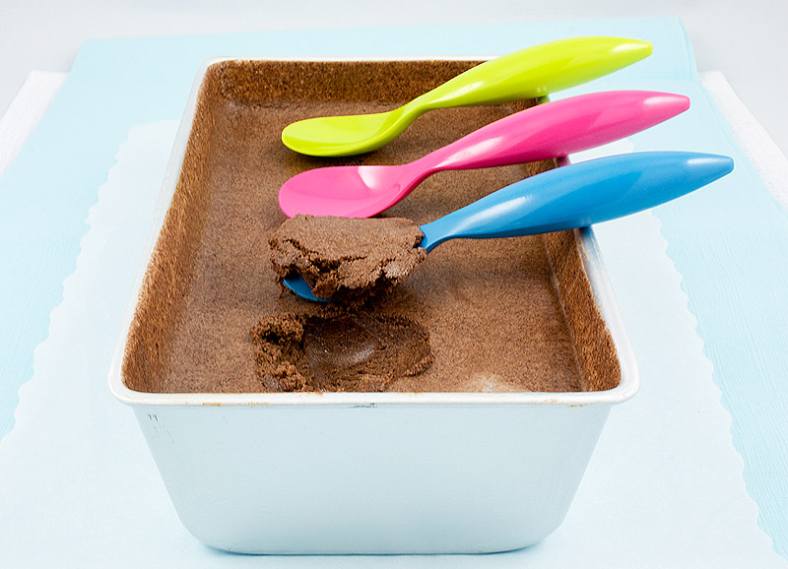
Ingredients:
- 125g caster sugar
- 4 eggs
- 250ml crème fraiche (half fat)
- 100 ml extra thick single or double cream
- 2 large Mars Bars (51g ones)
- 100g dark chocolate

How to make:
- Melt chocolate in bain marie.
- Chop mars bars and add to chocolate and mix in. Take off the heat.
- Stir in the double cream.
- Separate the eggs. Whisk egg whites with pinch of salt until very firm.
- Add the caster sugar to yolks and whisk until pale.
- Fold crème fraiche into the sugar/egg yolk mixture. Then fold in the chocolate mixture.
- Fold in the egg whites.
- Scoop mixture into large soufflé dish or ice cream carton and freeze for 24 hrs.
- Take out of freezer 20 mins before serving.
Mud Pie

For the Pastry
Ingredients:
- 175g plain flour
- 100g cold butter
- 25g icing sugar
- 1 large egg
- 1 tablespoon cold water.
How to make it:
- Mix the flour, butter and icing sugar in a food processor till it looks like breadcrumbs then add the egg yolk and water and mix again till it clumps together.
- Then put your clump of pastry onto a floured work surface and gather it into a ball. Knead it a bit to make it smooth then roll it out to fit into your pie tin. To make it fit draw a circle the same size as your dish (including the sides) onto greaseproof paper, sit the dough on it then roll it out to fit.
- Then grease your dish and plop in the pastry. Lightly prick the pastry base with a fork then chill for 30 minutes.
- When you get the pie base out of the fridge, put some greaseproof paper over it and fill with baking beans. Put it in the oven at 200 for 12-15 minutes then remove the paper and beans and put it back in for another 10 mins. This is called ‘blind baking’.
- Leave it to cool, turn down the oven to 170 and make your filling.

For the Filling
Ingredients:
- 150g dark chocolate roughly chopped
- 50g unsalted butter
- 30ml golden syrup
- 6 eggs
- 300g light soft brown sugar
- 1 teaspoon vanilla extract.
How to make it:
- Put the chocolate, butter and golden syrup in a pyrex bowl over a pan of simmering water (it’s called a bain marie) and let it melt together. Mix it round, let it cool a bit.
- Put the eggs, sugar and vanilla into your food processor and mix until well combined. Then you add the chocolate mix until smooth.
- Pour into your pie crust and bake for 30-40 minutes. When it’s cooked it will be firm to the touch.
- Once your pie has cooled you can top it with whipped cream and chocolate sprinkles. Nom Nom.

Easy Chocolate Treats

Ingredients
- A bar or two of chocolate! (150g bar makes 10-12 little choccies. We use Tesco Rainforest bars or Cadbury fair trade)
- Optional add ins – nuts, bits of dried fruit etc

How to make them
- Break up milk, white or dark chocolate.
- Melt gently in bain marie or microwave
- Pour into ice cube tray or cute moulds with any add-ins
- Put them in the fridge to let them set then pop them out and scoff

Nutty Chocolate Truffles

Ingredients
- 50g dark chocolate
- 150g nutella or similar choccie/hazelnut spread
- 2 tablespoons double cream
- Optional – ground almonds or something else yummy to coat them in
How to make them
- Break the chocolate into pieces and put it in a saucepan with the cream and Nutella.
- Mix thoroughly until well combined, then remove from heat and leave to cool.
- Use a melon baller or teaspoon to scoop up small pieces of the chocolate mixture.
- Roll in palm of your hand to form a ball – repeat until all the mix is used. (you’ll get about 12-15)
- Roll balls in ground almonds.
- Refrigerate for 30 minutes before serving and scoffing

Posh Chocolate Truffles

Ingredients
- 300g good quality dark chocolate – at least 70% cocoa solids
- 300ml double cream
- 50g butter (if unsalted add pinch salt)
- Optional flavourings eg orange zest and toppings – chopped nuts/cocoa powder
How to make them
- Break the chocolate up into small pieces and put it in a large bowl.
- Put the cream in a pan and heat gently until little bubbles start to appear – then bung in the butter.
- When the butter has melted take pan off the heat and pour over the chocolate pieces – whisk till chocolate melts.
- When the mixture is smooth add any flavourings and shove it in the fridge – it will take a while to set maybe 2 hours
- Get it out of the fridge, let it come to room temperature and then scoop out balls of it and coat with chopped nuts or cocoa if you like

Raw Chocolates
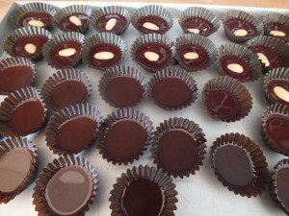
Ingredients (you can get these from Choc Chick)
- 100g Raw Cacao Butter
- 6 Tablespoons Raw Cacao Powder
- 2-4 Tablespoons Sweet Freedom or Agave Syrup
- Optional: Small pinch of rock or sea salt

How to Make
- Gently melt the cacao butter in bain marie.
- Whisk in the cacao powder then add the syrup.
- Taste for sweetness, add bit more syrup if need be.
- Pour into moulds or icecube trays or cute little cases. Bung in any add ins you want.
- Put in freezer for 20-30 mins to set or in fridge for 2 hours.

